## Can Can Soccer (version 20170605)

**Robot Size limit** : 18 x 18 inches

**Robot Weight Limit** : 15 pounds

**Robot Control** : Autonomous

**Game Duration** : Single 5-minute period

**Arena** : 7 x 10 feet

**Overview:**

Two robots start in opposite goals in an arena consisting of a rectangular walled field, resembling a soccer field, with six randomly placed empty soda cans wrapped in fluorescent orange duct tape. Both robots attempt to move as many of the cans on the field through their opponent's goal in the allotted time while avoiding the opponent. Dynamic obstacle avoidance makes the event very interesting. Aggressive behavior against the competing robots is not allowed.

**Objective:**

* Place as many cans as possible into the opponent’s goal
* Avoid collisions with opposing robot

**Rules**:

* Arms, claws or other can manipulators cannot extend the robot size beyond 18 x 21 inches
* A robot may only have control of one can at a time
  + Control is defined as possessing or moving a can.
  + If a robot controls a second can, the judge may relocate the can back on the field.
* Robot may start anywhere inside the starting area facing any direction.
* No aggressive behavior towards opposing robot
  + Incidental contact will be ignored
  + The judge(s) will determine what's aggressive or not
* Beacons or other navigational aids are allowed
  + They must be outside of the walled area along the longer sides of the field.
  + They cannot be in the shorter side of the field or the area near or at the goals.
  + They must not affect the performance of competing robots. For example, a beacon with an active ultrasonic or IR transmitter is not allowed.
* Processing external to the robot and via wireless communication is allowed
* The fluorescent orange color of the target cans cannot be used on a competition robot or on a beacon used in the competition. A competitor is also prohibited from wearing a fluorescent orange garment.

**Game Play:**

* Double elimination tournament
* For the initial round, “like” competitors will be matched against each other as determined by the judge(s).
* A round starts when the two competing robots are given a signal from the judge.
* The round ends whenever a robot places 4 cans into his opponent's goal or the time limit is reached.
* If the robots become interlocked or a robot is pushing or dragging a robot, the reset rules come into play.
* If the score is tied at the end of a round, cans will be reset for a two-minute sudden death overtime. First one to score wins. If there's no score the judge(s) will declare a winner.

**Game Reset:**

* Both robots return to their starting position
* Contestants can reinitialize their robot
* The game clock does not stop during a reset
* The judge(s) may choose to reset any can positions
* The judge(s) can call for a reset at any time
* A competitor can request a reset at any time, but it is the judges’ decision when to reset.

**Scoring:**

* 1 point for each can in the opponent's goal
* The can must completely cross the goal line
* A robot that places a can in his own goal, scores a point for his opponent
* The robot with the most points wins the round.

**Judging:**

The contest will have one or more judges. They will ensure the rules are followed and impose scoring penalties or remove a robot from competition if the robot is operating in an unsafe manner or not complying with the rules. The decisions of the judges are final.

**Can Specifications:**

* Empty standard size 12-ounce aluminum soda cans
* Wrapped in 1 to 2 layers of fluorescent orange duct tape
  + Duck Brand Model #1265019 Neon Colored Duct Tape
  + Available at Walmart, Home Depot, Staples, and Amazon
* Pull tabs may or may not be removed

**Safety:**

If the behavior of a robot is determined to be unsafe, the judge will withdraw the robot from the competition. Since pushing or “launching” cans is a legitimate strategy, the robot builder must take responsibility for limiting this ability so as not to create a safety hazard. The decisions of the judges regarding safety matters are final.

**Course:**

* Dimensions
  + 7 ft. wide x 10 ft. long
* Walls
  + Height – 8 in
  + Color - white
* Floor
  + The flooring of the room used for the competition, or such temporary material as is needed to protect that floor as deemed necessary by contest organizers and venue operators. This material could include wood, Tyvek, low-pile carpet, dense foam or other common flooring materials.
* Goals
  + 35 inches wide x 12 inches high
  + Centered on 7-foot wall
* Starting Area
  + 35 inches wide x 18 inches long
  + Marked by ¾ inch blue painters tape (optional – judges’ decision)
* Center Field
  + Marked by ¾ inch blue painters tape across the width of the course (optional – judges’ decision)

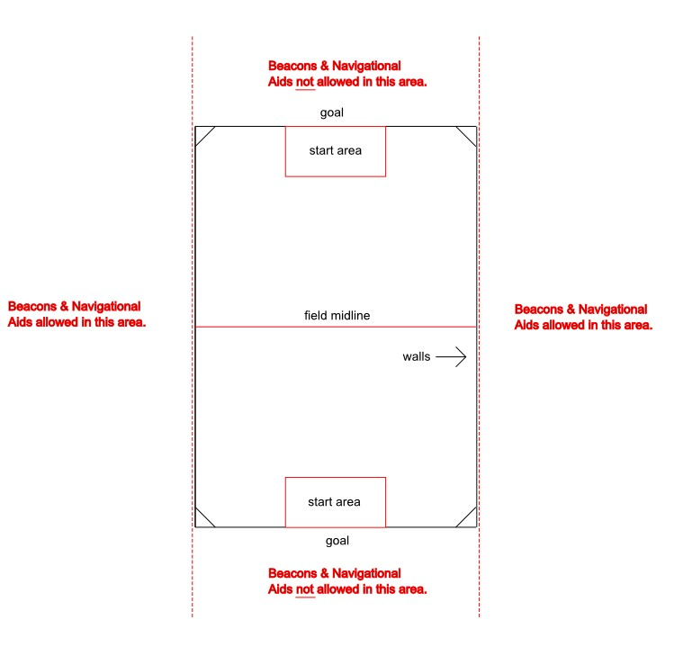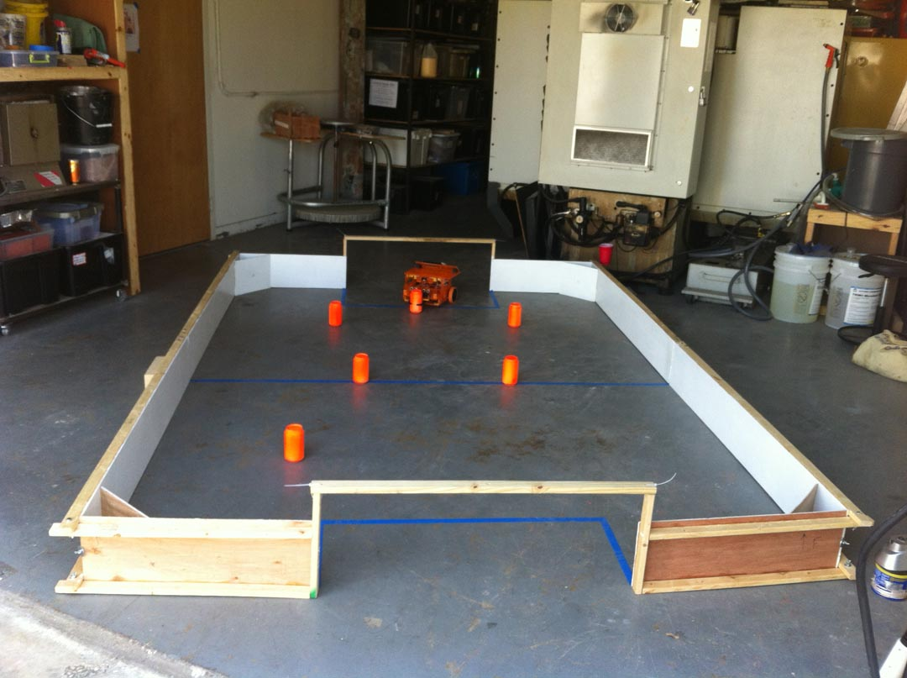

**Note:** The field diagram shows a small wall cattycorner to each corner of the arena. These pieces may or may not be used based on the decision of the judge at the time of the event.